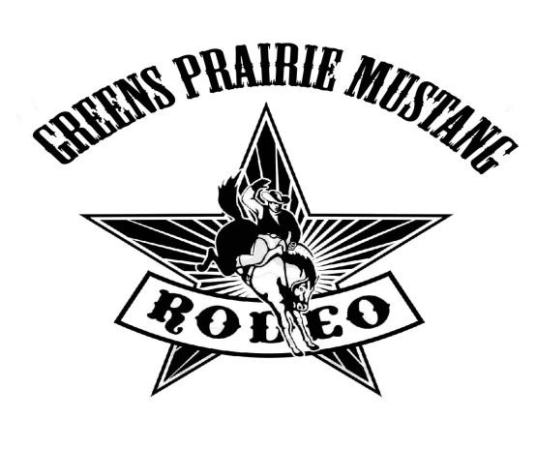
SUPPORT OUR SCHOOL BY BECOMING A SPONSOR!
We would like your support for the Greens Prairie Elementary School Sixth Annual Mustang Rodeo, on March 24, 2018. The funds from your sponsorship will be used to enhance children’s educational experiences in our school.
Your tax deductible contribution will provide your company with recognition at Greens Prairie Elementary and the satisfaction of giving to the children of your community!
Name/Company Name (as you would like for it to appear):_______________________________________________
Address:_________________________________________________________________________________________
Telephone Number:_______________________ E-Mail:__________________________________________________

Contact Person______________________________________
_______________________________________________________________________________________________________________________

SPONSORSHIP LEVELS:

_____ RHINESTONE COWBOY SPONSOR - $2,500
As a RHINESTONE COWBOY SPONSOR, your name and logo will be displayed on a prominent sign in the cafeteria as well as on display in the trophy case in the entrance to the building. Your name and logo will be displayed on our PTO website for the remainder of the year. Your company name will be recognized in the Rodeo brochure and your name will be displayed on the marquee for a designated time. Large logo on Rodeo T-shirts.

_____ TRAIL BOSS SPONSOR - $1,000
As a TRAIL BOSS SPONSOR, your name and logo will appear on a prominent sign at the Rodeo. Your company’s name will be recognized in the Rodeo brochure and your name will be displayed on the marquee for a designated time. Large logo on Rodeo T-shirts.

_____ CHUCK WAGON SPONSOR -$500
As a CHUCK WAGON SPONSOR, you or your company’s name will be recognized in the Rodeo brochure and your name will be displayed on the marquee for a designated time. Small logo on Rodeo T-shirts.

_____ SADDLE SPONSOR -$100
As a SADDLE SPONSOR, you or your company’s name will appear on a small sign next to one of the games and will be recognized in the Rodeo brochure.
Special Instructions for Sponsors on the back of this form.

Please indicate exactly how Sponsorship should be listed. Email your hi resolution (400dpi or higher) logo to either of the two contacts below.

SPONSORSHIP DEADLINE for program and t-shirt production – March 10, 2018.

Please make checks payable to Greens Prairie PTO.

I have enclosed check #________ in the amount of $___________

Credit Card #: Exp. Date:

Security Code: Billing Zip:

Signature:

A receipt, along with a copy of our Rodeo Program, will be mailed to you immediately after the Rodeo.

Greens Prairie Elementary PTO appreciates your support!

Mailing Address: 4315 Greens Prairie Trail, College Station, TX 77845
979-694-5870

For more information, please contact
Trudy Bennett (tbennett@tamu.edu), or Katie James (kjames@verisk.com).

